Agreement/authorisation to act as direct representative

Dotted lines indicate that further details must be provided. The “*” means “if applicable”.
Italicised passages indicate that a different arrangement is possible.

The Undersigned,
The Principal / the party directly represented

Company Name :

Address :

Postal Code, Place :

Country :

Trade Register - Registration no.: VAT-Id no:

EORI number:

AEO certificate nr*:

Your contact for customs affairs:
Name: E-mail:

The Freight Forwarding Company / Direct Representative

Company Name(s) : KUEHNE + NAGEL N.V. and KUEHNE + NAGEL LOGISTICS B.V.
(CoC nr. 24116891) (CoC nr. 16024021)
Address : BOOMPJES 40 BOOMPJES 40
Postal Code, Place : 3011 XB ROTTERDAM 3011 XB ROTTERDAM
The Netherlands The Netherlands

Name of your contact person at Kuehne + Nagel:

The parties declare to have agreed as follows:

The Principal authorises and places orders with the Freight Forwarding Company, in conformity with Article 18, and further, of the Union Customs Code (Regulation no. 952/2013/EU), against the agreed remuneration, to make the declarations prescribed in the customs legislation -and where possible in other legislation- ‘in the name and for the account of’ the Principal. This authorisation and the order apply to the shipment of goods presented by/on behalf of the Principal, for which the Principal has provided the Freight Forwarding Company with the records/information. This authorisation and the order comprise all acts and communications up to and including the completion of the verification of the declaration and those in connection with the issue of the communication of the amount of the customs debt.

Furthermore, the Principal authorises and commissions the Freight Forwarding Company to:
- submit requests for repayment/remission as well as to submit written objections relating to data incorrectly stated in the declaration compared to the information supplied when the order was placed;
- to proceed, at the request of the Principal, to submit request for repayment/remission as well as to submit written objections, because incorrect information was supplied when the order was placed;
- to submit written objections in relation to corrections up to the completion of the verification of the declaration.
- to directly receive duty and tax refunds on the bank account of the direct representative in case of refunds by Customs authorities after objections and / or request for repayment / remission
Separate, case-by-case agreements are required for making/submitting other requests, written objections and lodging appeals.
In connection with the authorisation, the Principal is obliged to hand over to the Freight Forwarding Company proof of the existence of the company, its current place of business and names of the person(s) authorised to lawfully represent the company, such as a recent excerpt of the company’s entry into the Trade Register of the Chamber of Commerce or a statement by the company to serve as evidence of the authority of the person issuing the authorisation. If the Principal is a private individual, that person must hand over a copy of his passport/identity card.

Article 1. GENERAL CONDITIONS

1.1 Unless otherwise agreed, the relation between the parties is governed by the Dutch Forwarding Conditions, with the inclusion of the Arbitration Clause. The most recent version of the Dutch Forwarding Conditions at the moment at which the acts/activities are performed, is applicable.
1.2 The following annexes form part of this agreement:
- The checklist regarding necessary information on the "arm's-length principle" of transfer pricing
- The ‘information and documents required’ checklist.
- The Dutch Forwarding Conditions.
  - Unless otherwise agreed, the Direct Representative shall, if this serves the interests of the Principal, on the basis of the information known to the Direct Representative, be present at the taking of samples and the examination of the goods.
  - The Direct Representative is entitled to refuse to perform acts and activities ensuing from this agreement/authorisation, providing he/it communicates this as soon as possible.

Article 2. OBLIGATIONS OF THE PARTIES

  - The Principal is obliged to provide the Direct Representative with all required records, information and data necessary for the execution of this agreement (also for each individual shipment/transaction), which may be required on the basis of the applicable rules and regulations and the present agreement.
  - In order to submit a correct customs declaration the Direct Representative must require from the Principal the required records, information and data, the relevance of which must be reasonably known to him/it.
2.3 The Direct Representative will make such declarations on the basis of the above data.

Article 3. PROVISION OF SECURITY / PAYMENT OF DUTIES AND TAXES

3.1 Unless otherwise agreed, use will be made of the facilities of the Direct Representative in order to provide security and ensure payment of duties, other charges and taxes to the Customs Authorities.

Article 4. OBLIGATION TO KEEP RECORDS

4.1 On the basis of the license to submit an electronic declaration to the Customs Authorities issued to him/it, the Direct Representative is obliged to keep records and keep the (original) documents and records pertaining to each declaration. The Principal is obliged to keep a copy of the documents and records provided by him/it for the same period of time.
4.2 Subject to Article 4.1, the Principal is under a statutory obligation to keep all data relating to the declaration, the records and other data in connection with the transaction on file insofar as these pertain to the declaration.³

Article 5.DuRATION AND TERMINATION/REVOCATION OF THE AGREEMENT/AUTHORISATION

5.1 This agreement/authorisation is entered into/applies for an indeterminate period of time, effective as of ………..
The agreement/authorisation may be cancelled/revoked in due observance of a term of one month.
5.2 Cancellation/revocation is to be effected by registered letter.
5.3 The provisions under this agreement/authorisation continue to apply also after cancellation/revocation, where relevant in connection with fulfilment of obligations imposed in the name of government.
5.4 The Direct Representative is entitled to keep the present authorisation also after revocation for the purposes of possible controls in the name of the government.

The Principal, lawfully represented by:

Full Name :

Position :

Date and Place :

Signature (and Company Stamp) :
NB. Please make sure all pages are signed.

Freight Forwarding Company, represented by:

Full Name : Jeroen Borst

Position : National Manager Customs

Date and Place : 12 May 2022, Rotterdam
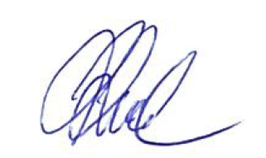

Signature (and Company Stamp):

KUEHNE + NAGEL N.V.
(KvK nr. 24116891)
BOOMPJES 40
3011 XB ROTTERDAM
Nederland

ANNEX
CHECKLIST: DIRECT REPRESENTATION
INFORMATION AND DOCUMENTS REQUIRED

The Principal shall supply the Direct Representative with the required records, information and data correctly and timely (prior to the moment at which a declaration is submitted). The checklist below has been composed to indicate what information and documents must be made available in general to the Direct Representative. If the declaration has been made and the Principal possesses records, information and data other than those supplied or listed in the declaration, he/it shall inform the Forwarding Company of this as soon as possible.

- GENERAL

- A recent excerpt of the entry of the company in the Trade Register (registration of the company and the signature authority)
- Name, address, place of residence of the Importer / Addressee and its VAT-Id no

- DOCuMENTs and RECORDS REQUIRED

- Invoice / statement of value
- (copy of) the Transport Document (e.g. B/L or CMR)
- Certificates of Origin/Provenance (depending on legislation)
- Other certificates (depending on legislation, such as health certificates)
- (copy of) Licenses (depending on legislation, such as import licenses, customs procedures with an economic impact license, particular destinations, exemption of customs import duties and/or other import taxes)

The Direct Representative is entitled to request the Principal to supply the following records:
- Packing list(s)
- Product specifications
- A copy of the contract of sale

- DATA REQUIRED FOR THE PURPOsE OF SUBMITTING A DECLARATION
The following information and data can be required from the Principal:

In relation to the shipment:
- Delivery terms (Incoterms 2010)
- Container number
- Mode of transport at the border and Inland mode of transport
- Country of dispatch/export and Country of origin
- Location of the goods

- Binding Tariff Information or Binding Origin Information, where present
- Description(s) of the goods and/or Commodity code
- Packaging unit, packages
- Marks and numbers
Gross mass and Net mass (for each Commodity code)

For the purpose of determining the customs value I (based on the transaction value)
- Costs of delivery to the point of entry, taking into account transport, costs of loading and handling and related to transport and insurance
- Costs of delivery subsequent to arrival in the EU (point of entry)
- Charges for construction, erection, assembly, maintenance or technical assistance, undertaken after importation
- Other charges included in the price (interest, duplication fees, buyer’s commissions, storage costs incurred in the EU and costs of safekeeping, quota costs and ‘sales’ tax)
- Customs duties and taxes payable in the Community upon importation/sale in the EU, already included in the price (such as DDP)

For the Purpose of determining the customs value II (based on the transaction value)
The following information, where applicable, must be disclosed to the Direct Representative, if:
- there is no contract of sale relating to ‘goods sold for export to the customs territory of the EU’
- several sales have taken place indicating that the goods are destined for the EU
- the seller receives part of the proceeds from a subsequent sale
- the seller and the buyer are in any way related (subsidiary, shareholdings, and so on)
- invoice inspection has taken place (date and outcome)
- there are discounts as to price, which are certain at the moment of importation
- the following costs are for the account of the buyer, but are not included in the purchase price
  - commissions (with the exception of buyer’s commissions)
  - brokerage fee
  - containers and packing
- goods and services supplied by the buyer are free of charge or at reduced cost for use in connection with the production and sale of the imported goods
- the buyer has to pay royalties and licensing fees, either directly or indirectly, as a condition of the sale
- the sale is subject to an arrangement by which part of the proceeds of the subsequent resale, disposal or use of the imported goods either directly or indirectly is for the benefit of the seller

- OTHER INFORMATION

If the Principal already possesses information of relevance or of possible relevance to the declaration, the Direct Representative must be informed of this. Examples are:
- Import and Export Regulations, special import rules (the Dutch Arms and Ammunition Act, the Dutch Opium Act, and so on, anti-dumping duties, compensatory duties, and so on)

Although this list has been carefully composed, the above description is not to be viewed as an exhaustive listing

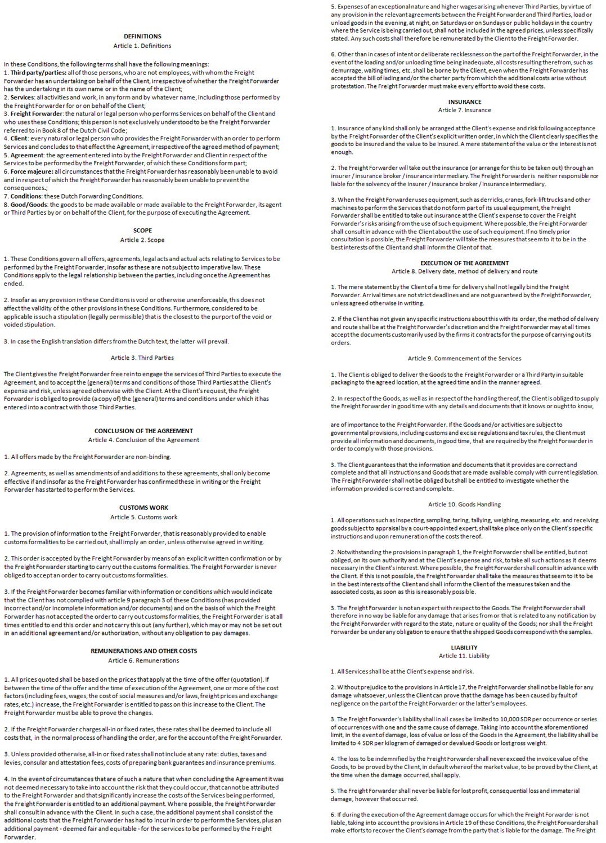

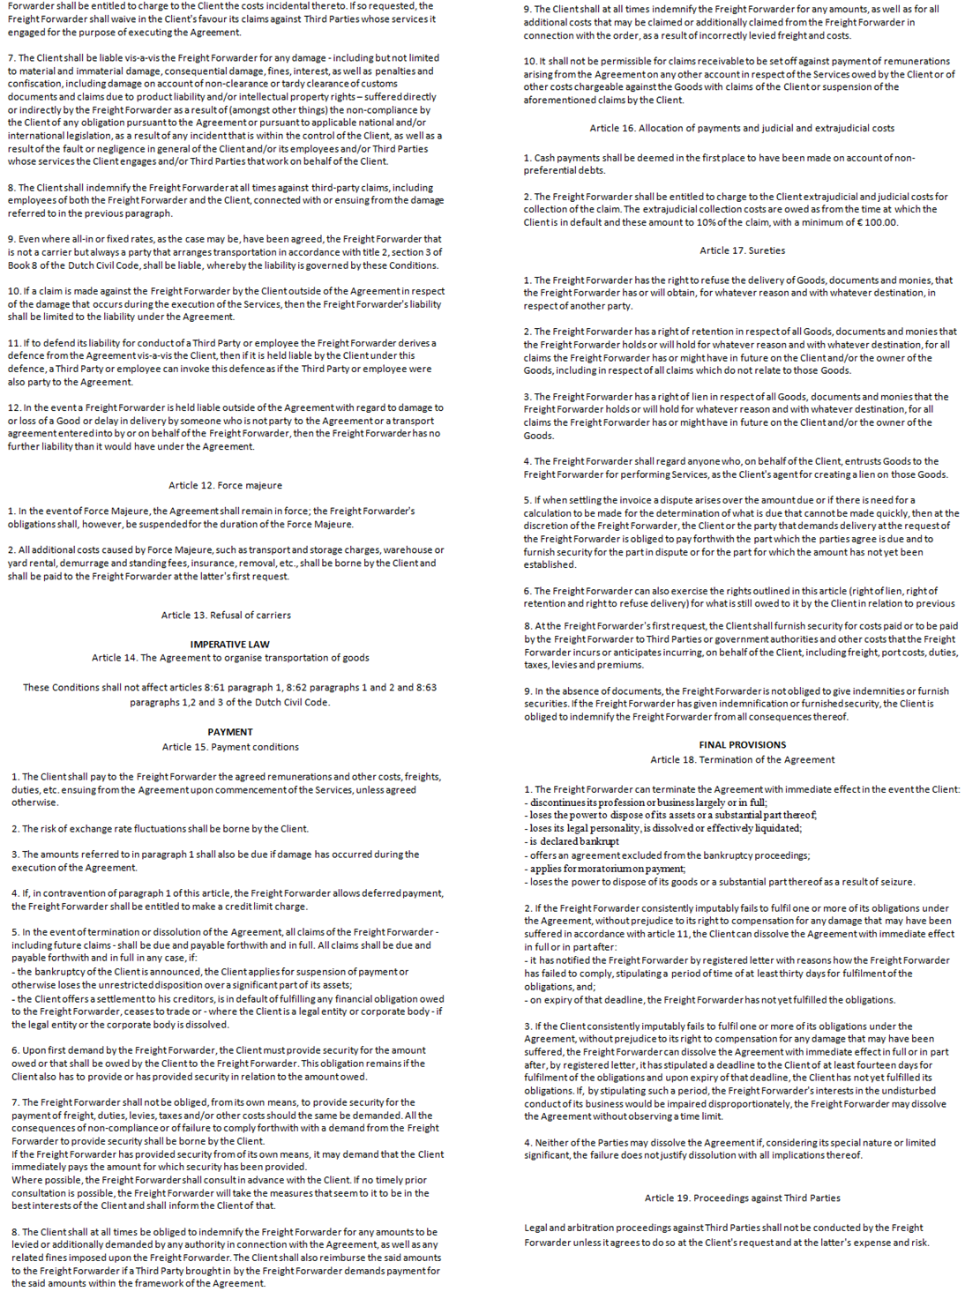
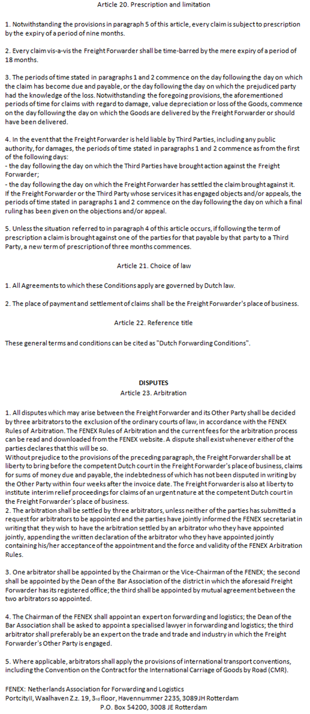

The Dutch Forwarding Conditions, deposited by FENEX at the Registry of the District Courts of Amsterdam, Arnhem, Breda and Rotterdam, may also be consulted at www.fenex.nl under ‘meer voorwaarden’.
It is advisable that the parties examine whether entering into further agreements is desirable in connection with the nature of the products, and so on.
To be kept for a period of 7 years from the date at which customs control was completed.
If that person/entity is not the principal as well.

